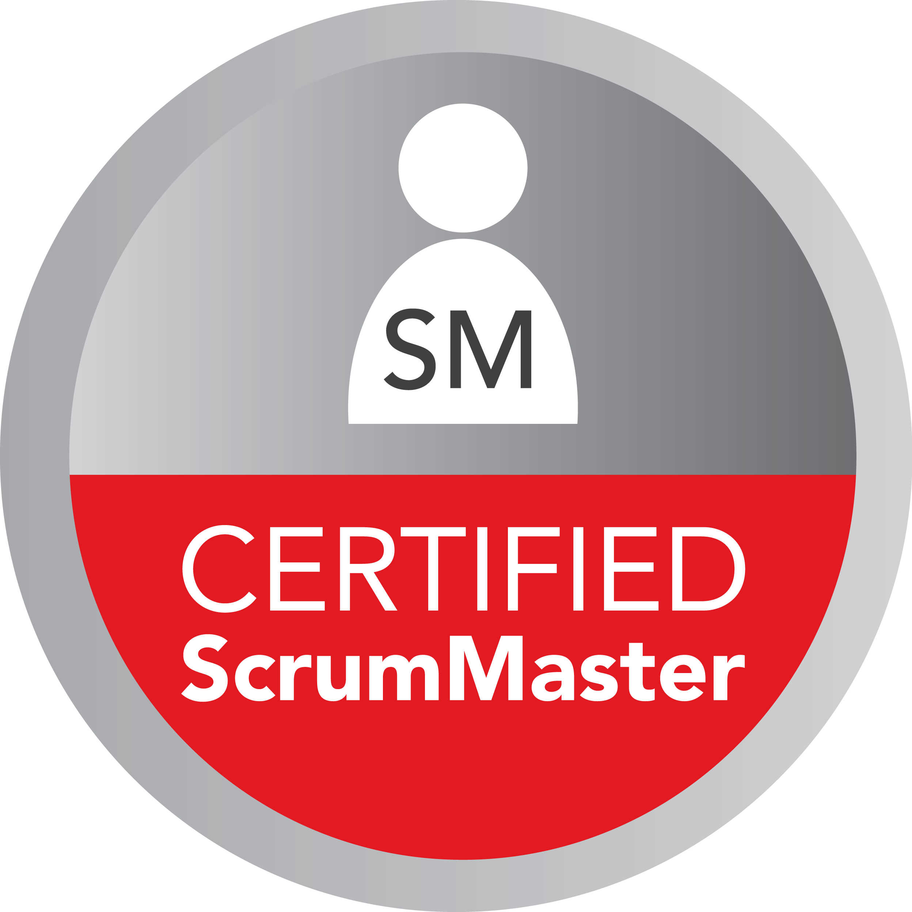 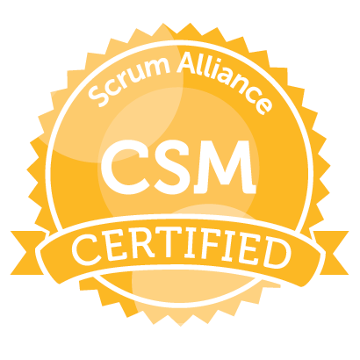

**Rahul S**

**Scrum Master**

**Professional Summary**

* 7+ years of extensive experience as a SCRUM Master, working in multiple cross-functional teams, dealing with stakeholders in different facets including business intelligence
* **Securities**, **Financial Instruments**, worked on regulatory and compliances like **Basel I, II & III Act, MiFID II, Sarbanes Oxley Act (SOX) act of 2002, Securities Exchange Act and basic of DTCC, FINRA, ISDA**
* Understanding of **Financial Statement Analysis, Capital Budgeting, Portfolio Analysis & Stock Valuation**
* Experience in working with different **Software Development Life Cycle** (SDLC) using both traditional and Agile methodologies such as **Waterfall**, **XP, Scrum-ban, Scrum, Waterfall-Scrum Hybrid** and **SAFe 4.0**
* Experience in working with large and diverse **cross-functional and self-organizing teams**
* Strong analytical, leadership and interpersonal skills; team-oriented and demonstrated ability to manage different and often conflicting objectives/activities at one time
* Expertise in analyzing, developing, and revising existing system logic difficulties and documenting as necessary and strong experience in **GAP** analysis to identify **AS-IS** and **TO-BE** system
* Facilitated **Sprint Ceremonies (Backlog Grooming, Sprint Planning, Daily Stand-ups, Sprint Review and Sprint Retrospective)** for each of **the Agile SCRUM methodology** sprints as a **SCRUM master**
* Expertise in handling **SCRUM artifacts** (Product Backlog, Sprint Backlog, Sprint Task list, Sprint Burn-Down chart and Release Burn-Down Chart)
* Led the breaking-down of **Epics** into user stories (**INVEST** format) and handled requirements churn
* Expertise in facilitating workshops for the **prioritization** and estimation of user stories using techniques such as **MoSCoW, KANO, planning poker and T-shirt sizing**
* Conducted **Velocity and Capacity driven** planning in sprint planning to track the progress of the team
* Experience in conducting document analysis, **Business Process Re-engineering** (BPR), **Business Process Improvements** and creating **Business Requirements document (BRD), Functional Specification document (FSD) and Use-Case Specifications**
* Identified and **Resolved Impediments** such as **Scrum Master owned Impediments, Organizational Impediments, and Team Owned** by coming up with a solution like **SWARMING**
* Extensive experience in communicating with **Subject Mater Expert** (SME’s), performing **Business Analysis**, **Data Analysis, Requirement Analysis, and Document Analysis**
* Experience in handling **Offshore Cross Functional and Self-Organizing Team** with **Continuous Coordination**
* Encouraged best engineering practices such as **Test-Driven Development (TDD), Acceptance Test Driven Development (ATDD), Behavior Driven Development, Continuous Integration and pair programming**
* Facilitated knowledge transfer sessions for the team at the team level in **SAFe environment** on DevOps and related tools like Jenkins for **Continuous Integration (CI**) and how to get data from repositories like **GitHub**
* Experience in writing **Acceptance Criteria** by understanding customer requirements
* Experience in formulating and defining project scope and objectives and developing system specifications from which programs will be written and that fit with the system architecture standards
* Experience in shielding team from external interference and distractions
* Experience in managing the scrum process with the coordination of scrum team in **Agile methodology**
* Experience in conducting retrospective session using techniques such as **Silent Writing, Mad Sad Glad, Happiness Histogram, ORID** to reflect the process of the teams according to the team’s need
* Expertise in reporting, data management, or data analysis and visualization using market leading commercial and open source tool like **JIRA, Tableau, IBM, Cognos, SSRS, SSAS, SSIS**
* Experience in assisting the lead user adoption and change management activities during inception, **User Acceptance Test (UAT)** and post implementation phases
* Excellent verbal and written communication skills, and comfortable interacting with technical and business stakeholders. Ability to explain complicated technical information in a simple way to non-technical audiences by using system metaphor

Tools

|  |  |
| --- | --- |
| **Project Management Tools/Methodology** | MS Project, Rally, JIRA, SAFe 4.0, Agile-Scrum, Waterfall-Scrum, Waterfall, Extreme Programming, Kanban, RUP, Rational Requisite Pro |
| **Defect Tracking** | JIRA, HP ALM, HP QC, Rational ClearQuest |
| **Modeling** | MS Visio, Smart Draw, Erwin Data Modeler, Mockup Screens, Balsamiq, Lucid Charts |
| **Reporting Tools** | Tableau, QlikView, MS excel |
| **Databases** | SQL Server, MySQL, PostgreSQL, HBase, Oracle 11g, |
| **Big Data Tools** | Apache Hadoop, Hive, AWS Redshift, Sqoop, Flume NG, Storm, Kafka, HBase, Pig Latin, Zoo keeper, Financial Service Cloud SalesForce |
| **Testing Tools** | HP QC, HP ALM, QTP, Selenium, Load runner, Postman, Cucumber and SOAP UI |
| **Data Warehousing** | Data Marts, Data Modeling, OLAP, OLTP, Data Mining, ETL, Informatica Power center 9.6.1, Slicing/Dicing, Drill Down/ Roll up, Pivot, Star and Snowflake Schema |
| **Business Skills** | Change Management, Impact Analysis, Risk Analysis, Cost-Benefit Analysis, JAD Sessions, requirements elicitation, SWOT analysis, Gap analysis and Root cause analysis |
| **Web Services API** | SOAP, REST, XML, JSON, FIX |

**Bachelor of Engineering**

**Anna University, Chennai**

**Certified Scrum Master with a proven track record of working with self-organizing and cross-functional teams.**

|  |
| --- |
| **Charles Schwab July 2017- Oct 2018**  **Senior Scrum Master Phoenix, AZ** |
| The scope of the project was to develop Order interfacing modules (OIM) which update the Order Management System (OMS) in response to orders executed at the Electronic Trading Marketplace (ETM). This system involved integration of ETM with OMS to automate the execution of orders of securities in accordance with order generation, compliances check and liquidity support. OMS stores required data using Oracle ERP to manage its order flow, to monitor the initiation, placement, and execution of orders. |

**Responsibilities:**

* As a Scrum Master facilitated scrum events including **Sprint Planning**, **Stand-Up Meeting, Backlog Refinement, Sprint Review** meeting and **Sprint Retrospection** meetings
* Assisted Product Owner in hiring and deploying resources. Assisted Product Owner in identifying the **dependencies**, some of them are **organizational Impediments**
* Ensure timely delivery of projects/products in line with agreed functionality, quality, cost and performance in compliance with company procedures and standards, thereby assuring operational success of the product
* Define business requirements with the stake holders and translate those into a project plan with full involvement of the project team. Monitor maintain and report (to team, customers, project office) on the project status on a continual basis and for the duration of the project
* Make sure the project stays on track by pro-actively controlling actual status of cost, schedule, quality and resources versus plans and by tracking corrective **action- resolving cross- departmental conflicts**
* Manage project risks (**security, resources, budget, quality**) escalating issues and making proposals when appropriate
* Secure optimal resource utilization (staff, infrastructure, and budget) and match resource levels to project needs (especially people and infrastructure)
* Define the responsibilities of project members in partnership with line management motivating team members, providing regular feedback, positive recognition, and conducting project appraisal
* Assisted team to adapt Scrum documentation - to create **Product Backlog** with **User stories, Sprint Backlog, Sprint Task List, Sprint Burn down and Release Burn Down charts using JIRA**
* Used multiple prioritization and estimation techniques - **MoSCoW, Kano, T-shirt sizing, Planning Poker** to prioritize user stories depending on business value and customer satisfaction
* Assisted Product Owner in writing **Acceptance Criteria** for user stories, **Definition of Done** (DOD) for **PSPI**'s
* Implemented process improvements techniques and ensure that there was room for change. Introduced a checklist during story time to ask the right questions while reviewing each story
* Reported defect status to business users and serious management by using **Tableau 9.1 and JIRA**
* Used JIRA tool for **Sprint planning, Sprint backlog management, Sprint Task list management, task allocations and report generation**. Generated reports to **track team velocity, issue tracking, team work load tracking and response time tracking**
* Assisted the Product Owner to construct a project plan that included **Project Schedules, Milestones** tracking, and Meeting minutes using **MS Project and MS Office**
* Hosted **Web-Ex meetings** to coordinate with service provider and service consumer and to streamline the deliverable to address dependencies

Environment: **Agile-Scrum Methodology, Jira, Tableau 9.1, Oracle 11g, MS Project and MS Office**

|  |
| --- |
| **Morgan Stanley Mar 2016- June 2017**  **Scrum Master New York, New York** |
| Fixed Income Performance Attribution System (FIPA) was developed specifically to support Wealth Management Groups to provide most valuable advisory services to clients on Asset Projections, stock option models, Portfolio Rebalancing, Investment Holdings, Liquidity needs, and future goals |

**Responsibilities:**

* Gathered and finalized user/business requirements to enhance **Wealth Management** workflow by integrating different applications, generated business models and use case analysis
* End to end Understanding of **Business Process,** working with all areas of the business to understand reporting needs
* Facilitated and managed meeting sessions with **Stakeholders.**
* Exhibited **lean-agile leadership** to help team to adopt and apply **SAFe** Principles, implemented **SAFe** practices
* Supported team in **Built-in-Quality** practices from **Extreme Programming** (XP), **Work in Process** (WIP) limit using **KANBAN**, and any other process rules the team had agreed
* Participated in **PI Planning** to do check-adjust (**PDCA**) and to cadence based interval for building and validating a full system increment.
* Facilitated the team’s progress toward team goals by continuously engaged in challenging the old norms of development to improve performance in the areas of **quality, predictability, flow and velocity**. Helped the team focus on daily and iteration goals in the context of current P**rogram Increment** (PI) objectives
* Facilitated all team meetings like **Daily Stand-Up**, **Iteration Planning, Iteration Review and Iteration Retrospective**
* Helped Product Owner in their efforts to manage the backlog, Shielded team from external interference
* Eliminated **Impediments** such as blocking issues and beyond the team’s authority, constantly addressed these issues so that the team can remain focused on achieving the objectives of the Iteration.
* Represented the team at the **Scrum of Scrum** (SOS) meeting to report progress and passed information from that meeting back to the team
* Assisted the team in preparation for **ART** activities, including **PI Planning**, system demos and the inspect and adapt meetings
* Helped teams in estimating **Features and Capabilities**

Environment: **SAFe 4.0, MS Office, Financial Service Cloud SalesForce, Tableau, MS Visio, JIRA,**

|  |
| --- |
| **Silicon Valley Bank Jan 2015- Feb 2016**  **Scrum Master Santa Clara, CA** |
| The objective of the project was to build the Enterprise Reporting System to analyze and understand the performance of its financial products like Deposits, Business and Personal loans, Wealth Management, Cash Management, and Merchant Services and doing analysis to improve customer experience |

**Responsibilities:**

* Defined **Project Scope** and objectives through internal P**roject Management Methodologies**
* Experience in **Scrum Teams** working on reporting tools for **Data Standardization and Data Normalization**
* Created the strategy, product roadmap, scope prioritization, business development and communication for projects and enhancements
* Responsible for handling delivery of a website. Worked with Project Managers, Project leads and QA leads to come up with a **Release Plan** with various contributors of the project for communications, negotiations and setting realistic expectations on the deadlines and tracked assigned Tasks
* Guided data warehouse team and enterprise team which worked towards developing **Dashboarding and Reporting Solutions** to the **Enterprise Reporting System**
* **Helped in Prioritizing t**he **Product Backlog** by conducting requirement churning sessions
* **Facilitated** and actively participated in all the **Scrum activities: Release Planning, Sprint Planning, Sprint Review, Sprint Retrospective and Daily Scrums**
* Worked with teams and understand their needs and difficulties to help them better and increase the overall velocity
* Kept a track on **Inter-Dependencies** between the teams and blockers and guided the team to handle them accordingly. Removed roadblocks for successful iterations, which led to the transition of releases on time
* Scheduled meetings and touch bases in order to create **transparency** between the product owners and the teams
* Prepared **Sprint Reports and Burndown Charts**
* Released Sprint based on the complexity of the user story and made sure the working product is satisfactory
* Made sure all the **Quality assurance tests** were carried out as per the release criteria and had enough time for hardening

Environment: **Agile-Scrum, AWS Redshift, HP Quality Center, XML, Rational Rose UML, SQL server, ASP .net, Mockup screens, MS project, QlikView 10X, HP ALM**

|  |
| --- |
| **NatWest Oct 2013 – Dec 2014**  **Scrum Master Stamford, CT** |
| The goal of the project was to migrate a company’s operational data to Enterprise Datawarehouse (EDW). As a systems analyst played a key role in building Enterprise data warehouse and helps business users of different departments in generating the reports as per regulatory rules |

**Responsibilities:**

* Gathered, Analyzed, documented business and technical requirements from both formal and informal sessions and validated the needs of stakeholders and assisted in **GAP Analysis** to derive requirements for existing systems
* Carried Walkthrough with Team and Quality Analysts to understand functionality in order to improve quality
* Constantly updated the **Business Requirement Document** (BRD), **Functional Requirement Document** (FRD) and created **Ad-Hoc Report** by chip in **Data Manipulation Language Query** (DML)
* Conducted **JAD sessions,** interviews with business users to gather requirements for system exploration and design
* Maintained **Excel** sheets, by developing **Pivot Tables**, Exporting Data from External databases, producing reports
* Drafted **User Stories** by specifying in Scope, Out Scope, **Acceptance Criteria**, open items and references in **Rally**
* Defined Data Dictionary, categorizing data into various subjects like name, data type, organization and update date
* Created **Data Mapping** using the transformations like Source qualifier, **Aggregator, Expression, Look Up, Router, Filter, Normalizer, Stored Procedure and Sorter Transformation** for both **OLTP** and **OLAP** System
* Participated in testing of procedures, data, utilizing **SQL**, to ensure integrity rules and quality in Data warehouse
* Created standard and complex reports to analyze using **Slice** and **Dice** and **Drill Down**, in **SSRS**
* Optimizing and Tuning several complex **SQL** queries for better performance and efficiency by adding indexes
* Performed **integration, black box**, scenario, regression, negative, process flow, sanity and **End-To-End testing** on the system to ensure the proper functioning of the data warehouse and conducted **ETL** workshops to understand requirements for Data Warehouse Design (**Extraction, Transform and Load**) operations on the database.

Environment: **Agile, Rally, MS Office Suite, MS SQL Server, SSRS, SSIS, SSAS, SQL, T/SQL, UML, MS Visio, MS Project, OLAP, OLTP**

|  |
| --- |
| **State Bank of India Nov 2012 – Sep 2013**  **Junior Business Analyst Pune, India** |
| SBI Capital Markets is amongst the oldest players in the Indian Capital Markets, offering an entire range of Investment Banking Services. It is one of the leading market players in the areas of fund raising through Capital Market issues |

**Responsibilities:**

* Interacted with Users and Stakeholders to identify business system needs, evaluated solutions for business problems
* Worked with **SME’s** of different groups to gain detailed knowledge of Investments and **Capital Market**, and to understand the cross impacts of the system
* Analyzed and documented information system requirements and the corresponding impact on business processes
* Prepared **Business Requirement Document** (BRD), supporting documents containing essential business elements, detailed definition and description of the relationship between the actors
* Worked on the Functional Requirements Document (FRD)
* Created **Use Case Diagrams**, **Activity Diagrams**, and **Data Flow Diagrams** to define the Business Process
* Analyzed the data entity relationships and worked on multiple short-term projects in between.
* Worked with other business analysts to make an object-oriented model of the application and created **use cases**
* Conducted **JAD sessions** to allow different stakeholders to communicate with each other
* Hands on experience in working with **active directory**, to give privileges and access to the users according to their roles and designations
* Analyzed **Business Requirements** documents to get a better understanding of the system on both **Technical and Business perspectives**

Environment – **MySQL, Java/J2EE, Active Directory, Rational Rose, SDLC, UAT, UML, MS Office, MS projects, MS Visio.**

|  |
| --- |
| **WNS Global Services Aug 2010 – Oct 2012**  **Python Developer Chennai, India** |

**Responsibilities:**

* Implemented Python automatic testing framework and assisted in maintaining Web application.
* Performed **regression**, and **performance testing** to certify the stability and usability of software systems.
* Developed monitoring and notification tools using Python
* Participated in requirement gathering and worked closely with the architect in designing and modeling.
* Created Data tables to display customer information and add, delete, update customer records using **Python**, **MySQL,** and **XHTML**
* Used Python for the functionality filtering of columns helping customers to effectively view their transactions and statements. Implemented navigation rules for the application and page outcomes, written controllers using annotations
* Written queries in **HQL** and **Native SQL** and criteria API
* Added the navigations and paginations and filtering columns and adding and removing the desired columns for view utilizing Python-based GUI components
* Test the application on different browsers and different operating systems
* Built application logic using Python, used the Framework to develop the application.
* Used Django APIs for database access
* Wrote Python scripts to parse **XML** documents and load the data in the database
* Utilized Python to provide **GUI** for the user to create, modify and view reports based on client data

Environment **Python, MySQL, HQL, Native SQL, Regression testing, Performance testing**